Divyansh Srivastava, Sneha Ravikuma, Taj Poovaiah Palecanda

**GROUP 11**

Database design and management | April 6, 2016

INFO 6210 Final Team Project

Schools_K12_DW –> Project PART 1 (Draft)



# Question 1

## Dimensional data model for data subsets

### Absence

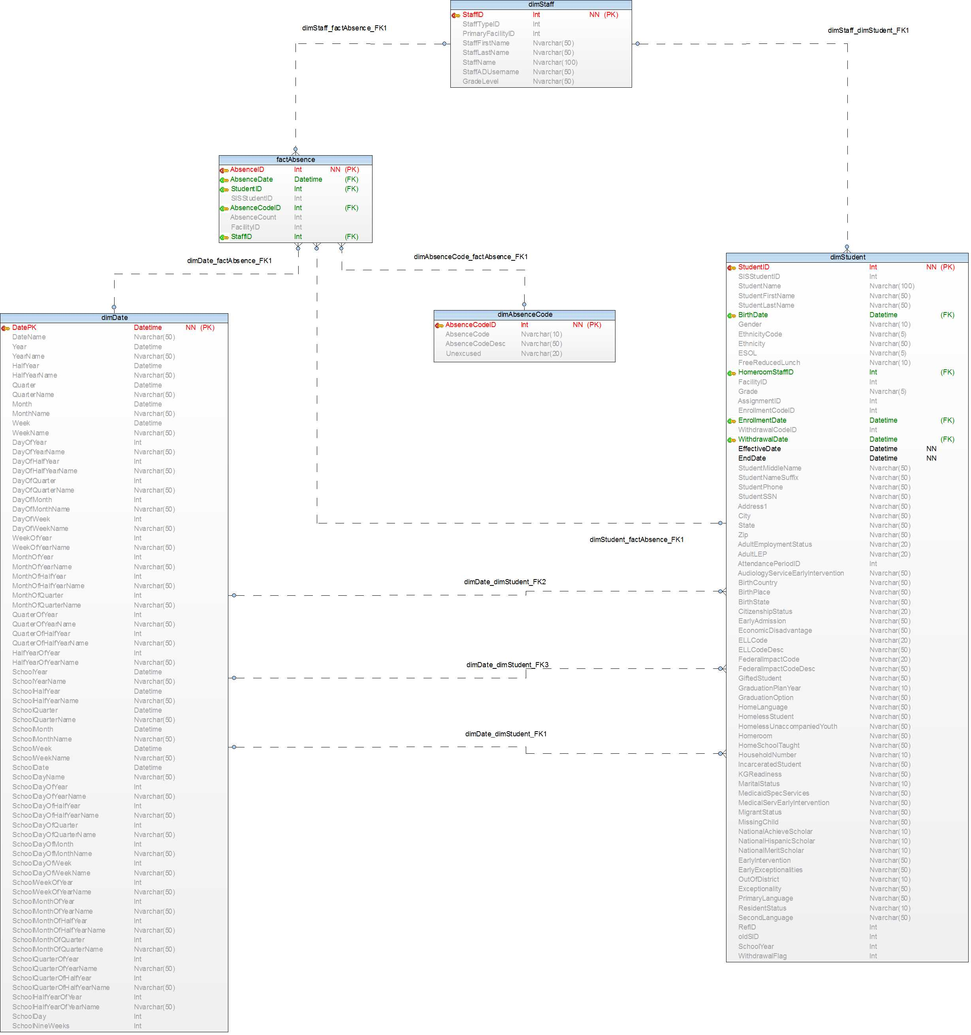

### Discipline Behavior

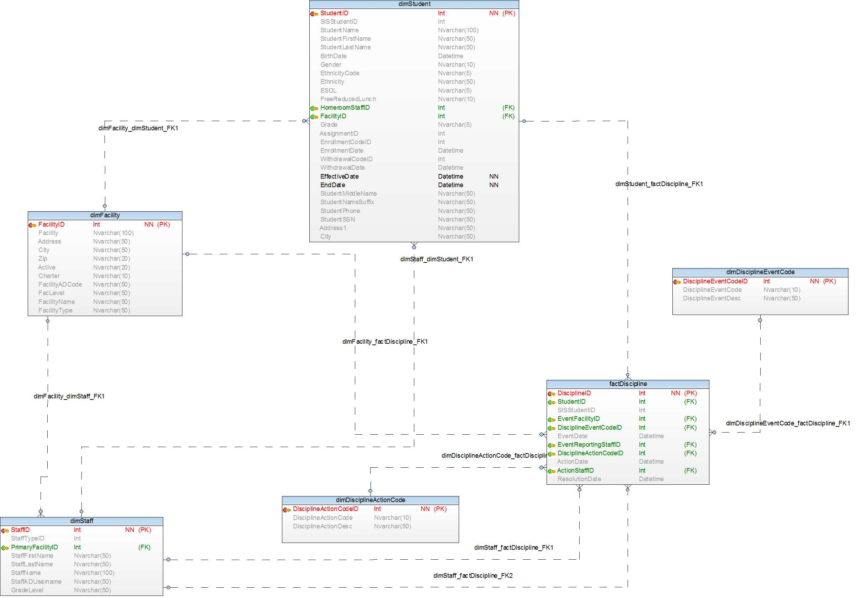

### Academic Performance

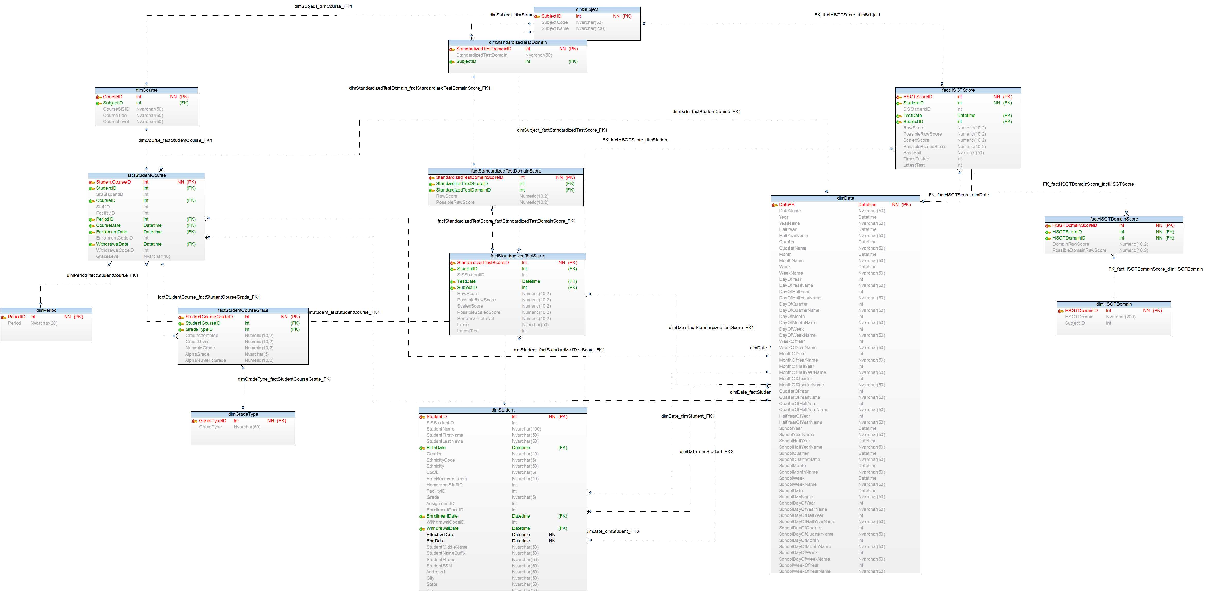

### Special Programs

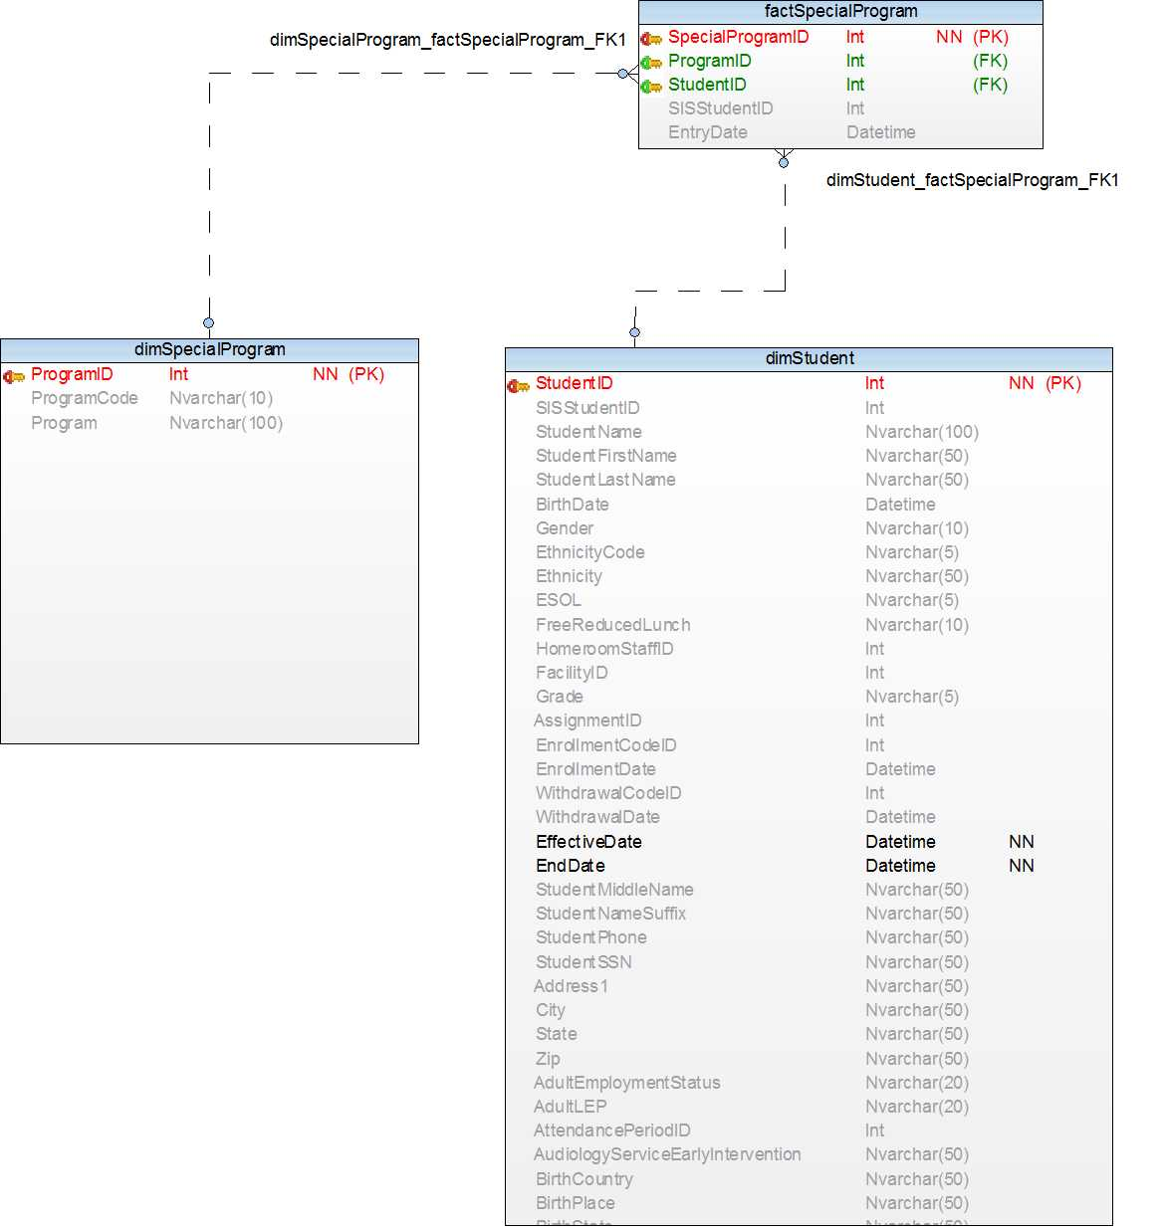

NOTE: These models may/ may not change based on project’s final version. DimParent table is yet to be introduced in performance model which will be one to one relation with DimStudent for Parent to see his child’s performance.

# Question 2

## Role based descriptions

Each role can perform these tasks:

### School Administrator

**Task and description:** List of faculty - Filters  
 Faculty information  
 Student Enrollment  
 List of student – Filters  
 Get student details  
 Discipline  
 Absence  
 Course (addition/ deletion)  
 Subject (addition/ deletion)  
 Discipline event

The school Administrator can view the list of faculty in school, view the details of each faculty member, manage the student enrollment, view the list and details of students, fetch student details such as discipline and absence, manage and monitor the facilities of the school, modify the courses and subjects, and manage the rules and regulations of the school through the disciplinary event.

### Teacher

**Task and description:** List of Student in class-Filters  
 Student Information  
 Course Information  
 Subject Information  
 Adding Test Scores  
 Update Test Scores  
 Update Grade  
 Adding Assignments   
 Grading the Performance of Assignments  
 Monitor the Absence of the student in class  
 Monitor the discipline of the student in Class

A teacher has the access to view his student information based on different criteria like course/ subject etc. Teacher has read access to student’s basic personal information but write access to other information like updating test scores, updating grades etc.  
A teacher can add/ update/ delete assignments and grade the performance of the student. He can monitor the student performance too. Similarly, Teacher can add/ modify student’s absence in the class and take any disciplinary action against the student.

### Parent

**Task and description:** Student Information  
 Monitor the performance of student  
 Monitor the Absence of the student  
 Monitor the discipline of the student

Parents can access only the details of their own child/children. Each parent will be associated with one or more student ID. The student table will have the parent(s) ID. The following functions can be performed by the parent for the students they have access to: Child’s grade, absence, discipline

## Role based Queries

### School Administrator

Absence

select f.AbsenceCount,f.AbsenceDate, d.StudentName, s.StaffName

from factAbsence f INNER JOIN

dimStudent d ON d.StudentID = f.StudentID

INNER JOIN dimStaff s ON

s.StaffID = f.StaffID;

Discipline Behavior

select s.StudentName,DisciplineActionDesc,e.DisciplineEventDesc

from factDiscipline d INNER JOIN dimDisciplineActionCode a

ON d.DisciplineActionCodeID = a.DisciplineActionCodeID

INNER JOIN dimDisciplineEventCode e

ON d.DisciplineEventCodeID = e.DisciplineEventCodeID

INNER JOIN dimStudent s

ON d.StudentID = s.StudentID;

Performance

Select co.CourseTitle,AlphaGrade,g.NumericGrade,su.SubjectName,h.RawScore,st.StudentName

from factStudentCourse c INNER JOIN factStudentCourseGrade g

ON c.StudentCourseID = g.StudentCourseID

INNER JOIN dimCourse co

ON co.CourseID = c.CourseID INNER JOIN dimSubject su

ON su.SubjectID = co.SubjectID

INNER JOIN factHSGTScore h ON

h.SubjectID = su.SubjectID INNER JOIN dimStudent st

ON h.StudentID = st.StudentID

Special Program

select dsp.Program,s.StudentName

from factSpecialProgram fsp INNER JOIN dimSpecialProgram dsp

ON dsp.ProgramID = fsp.ProgramID INNER JOIN dimStudent s

ON fsp.StudentID = s.StudentID

### Teacher

Student under one teacher (e.g. for staff id 10)

SELECT stf.StaffID,stf.StaffName, stf.StaffTypeID, ds.StudentName, ds.StudentID

FROM factStudentCourse fsc

INNER JOIN dimStudent ds

ON fsc.StudentID=ds.StudentID

INNER JOIN dimStaff stf

ON fsc.StaffID=stf.StaffID

where fsc.StaffID=10

Student information for all students under one teacher

Select * from dimStudent ds

where ds.StudentID IN (

SELECT ds.StudentID

FROM factStudentCourse fsc

INNER JOIN dimStudent ds

ON fsc.StudentID=ds.StudentID

INNER JOIN dimStaff stf

ON fsc.StaffID=stf.StaffID

where fsc.StaffID=10

)

Student Information

Select * from dimStudent

where StudentID=47

Discipline Behavior

Select s.StudentID, s.StudentName,DisciplineActionDesc,e.DisciplineEventDesc, d.ActionDate

from factDiscipline d INNER JOIN dimDisciplineActionCode a

ON d.DisciplineActionCodeID = a.DisciplineActionCodeID

INNER JOIN dimDisciplineEventCode e

ON d.DisciplineEventCodeID = e.DisciplineEventCodeID

INNER JOIN dimStudent s

ON d.StudentID = s.StudentID

where s.StudentID=1;

Absence

select d.StudentID, f.AbsenceCount,f.AbsenceDate, d.StudentName, s.StaffName

from factAbsence f INNER JOIN

dimStudent d ON d.StudentID = f.StudentID

INNER JOIN dimStaff s ON

s.StaffID = f.StaffID

where d.StudentID=760;

Academic Performance

select c.StaffID,co.CourseTitle,AlphaGrade,g.NumericGrade,su.SubjectName,h.RawScore,st.StudentName

from factStudentCourse c INNER JOIN factStudentCourseGrade g

ON c.StudentCourseID = g.StudentCourseID

INNER JOIN dimCourse co

ON co.CourseID = c.CourseID INNER JOIN dimSubject su

ON su.SubjectID = co.SubjectID

INNER JOIN factHSGTScore h ON

h.SubjectID = su.SubjectID INNER JOIN dimStudent st

ON h.StudentID = st.StudentID

INNER JOIN dimStaff stf

ON c.StaffID=stf.StaffID

where stf.StaffID=35 AND st.StudentID IN

(

SELECT ds.StudentID

FROM factStudentCourse fsc

INNER JOIN dimStudent ds

ON fsc.StudentID=ds.StudentID

INNER JOIN dimStaff stf

ON fsc.StaffID=stf.StaffID

where fsc.StaffID=35

)

Special Program

select dsp.Program,s.StudentName

from factSpecialProgram fsp INNER JOIN dimSpecialProgram dsp

ON dsp.ProgramID = fsp.ProgramID INNER JOIN dimStudent s

ON fsp.StudentID = s.StudentID

### Parent

Academic Performance

View their child's grade

Select a.StudentFirstName,a.Grade

from dimStudent a

JOIN DimParent c

On a.studentID = c.studentID

WHERE parentCode=" "

View their child's scores

Select a.StudentName, c.SubjectID ,c.RawScore, d.TestDate, b.SubjectName

from dimStudent a

JOIN FactStandardizedTestScore c

ON a.studentID = c.studentID

JOIN factHSGTScore d

ON c.SubjectID = d.SubjectID

JOIN dimSubject b

ON d.SubjectID = b.SubjectID

JOIN DimParent f

ON a.studentID = f.studentID

WHERE parentCode=""

group by a.StudentName, c.SubjectID ,c.RawScore, d.TestDate, b.SubjectName

View their child's absence per subject/staff

Select a.grade from dimStudent a

JOIN factAbsence b

ON a.studentID = b.studentID

JOIN DimParent c

On a.studentID = c.studentID

WHERE parentCode=" "

AND StaffID=""

Discipline

Select DisciplineEventDesc, a.StudentID, EventDate, ActionDate

From dimStudent a

JOIN FactDiscipline b

ON a.studentID = b.studentID

JOIN DimDisciplineEventCode c

ON

b.DisciplineEventCodeID = c.DisciplineEventCodeID

JOIN DimDisciplineActionCode d

ON b.DisciplineActionCodeID = d.DisciplineActionCodeID

WHERE a.parentCode = ""